

FREE PUBLIC SHORE SAFARIS

July
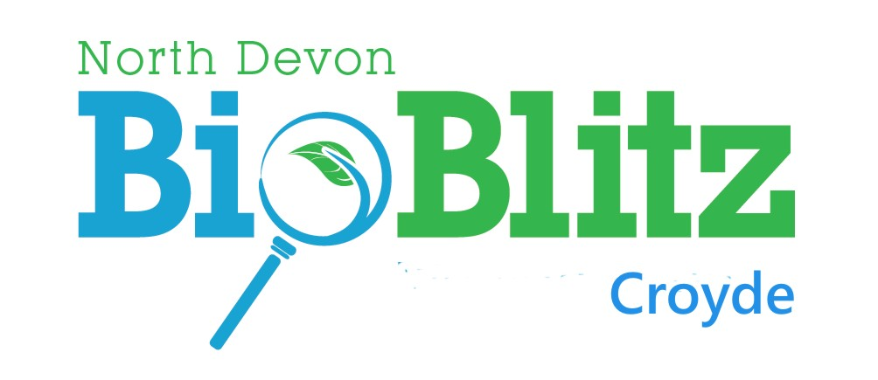
For North Devon Coast AONB
Coastal Creatures Project

CROYDE
Lime Kiln Field, Moor Lane
Near main beach slipway

SATURDAY 17 SEPTEMBER
10-00 am – 6-00 pm

Interested in the plants & animals of the shore & its fringes? Join us for a fun day finding out about the wildlife of Croyde, from sky to sea, bats to porpoises, & our speciality - lots of rock-pooling.

The day’s activities will start from basecamp where there will be plenty to interest you all day.

Free event. No booking required.



Sunday 24 Saunton 2.00
August
Tuesday 2nd Croyde 10.30
Friday 5th Lee Bay 12.30
Friday 19th Westward Ho!
11.30

Meet bottom of main slipway

Join our local group to explore the rock-pools & find out about the creatures that live there.

For late changes check Facebook, or call Jim Monroe
01271 882078 / 07889 134466

Participants responsible for own safety. Dress for the weather with footwear for rocks & sea. Under 16s to be accompanied.

MONITORING WITH SHORE THING
A Marine Biological Society Project
Interested in learning even more? Join us as we get down to creature counting, no previous experience needed.
20 July Lee Bay 11 am, on beach
22 July Abbotsham,12 noon Seafield car park

Coastwise North Devon is a local voluntary group that champions the coast through programmes of talks and shore activities.
Secretary mheath2025@gmail.com

www.coastwisenorthdevon.org.uk



