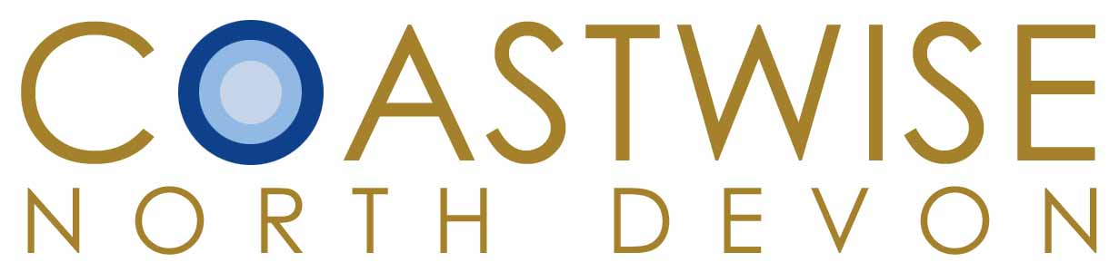

**AUTUMN PROGRAMME 2024**

**10 OCTOBER – 12 December**

Usually Thursday mornings 10-12, Barnstaple Library Room 2A, all welcome

10 October “Riverwoods”, salmon decline & what to do about it, with Cllr Adrian Bryant, Wayne Thomas of ND Angling News, & NT’s James Thomas.

17 October ND National Landscapes’ Jamie Buxton Gould and Evie Giblett on Finding Nature’s Footprints work with communities.

24 October 9.30 am Birding Trip to Horsey with birder Rob Jutsum, meet at Velator car park, Braunton.

31 October Robert Durrant, and the making of the film: Lundy, the glory of the Bristol Channel.

7 November North Devon Maritime Museum, Appledore visit with guides Judith Tatem & Martin Corfe, meet there at 10 am.

14 November Orlando Venn, WWT Principal Project Officer for Coastal Wetlands, on The Superpowers of Salt Marshes.

21 November John Balls, Chair North Devon Fishermen's Association on 'The Fishing Industry through the eyes of a North Devon commercial fisherman.

28 November Our Shoresearch and INNshore (invasives) survey contributions 2024, members Debbie Frazer & Nicola Mello.

5 December Josh Day, National Trust Project Coordinator, Wildflower photography.

12 December Members’ Session

Membership £20 for 10 Sessions. Individual Library talks £3

For more information see [www.coastwisenorthdevon.org.uk](http://www.coastwisenorthdevon.org.uk)

or contact Membership Secretary at coastwisendinfo@gmail.com

FACEBOOK - Coastwise North Devon