
September 2012

ATLANTIC ARRAY
A draft Environmental Impact Assessment was published in the summer. Coastwise responded, focussing on wildlife & seascape issues, and objecting strongly to the construction of the Atlantic Array in the proposed location. Many important species would be affected, given the key role played by the Channel in their lives. The modest levels of impact anticipated in the EIA were challenged, as was the claim that the visual impact on adjacent coasts would be slight.
Should planning approval be granted, mitigation measures were advocated including:
- independent research and monitoring leading to mitigation of impacts as they arise
- compensation for loss of seascape amenity
- eventual restoration of habitats

AUTUMN PROGRAMME
October
4 Andy Torbet, TV presenter & zoologist
Our coast as an adventure sports venue, good or bad?
11 Jay Nicholson, marine biologist
Seaweeds & their surprising lives
18 Visit to Chittlehampton Pottery
Roger Cockram in his element
25 Becky Seeley, Marine Biological Association.
Putting our marine life on the record
November
1 Steve Corcoran, Ilfracombe Aquarium
Looking after a cold saltwater aquarium
8 What do we know? Quiz
15 Rod Lawrence, naturalist
Ecology of Dune Succession Made Simple
22 Jen Ashworth, Natural England
Evidence for Marine Protected Areas - challenges and local opportunities
29 Todd Gray, historian & writer
North Devon's Elizabethan Fishermen
December
6 Paul Madgett, geologist
Waves - shapers of the shore

Jim Monroe, an enthusiast for the work of Victorian naturalists and
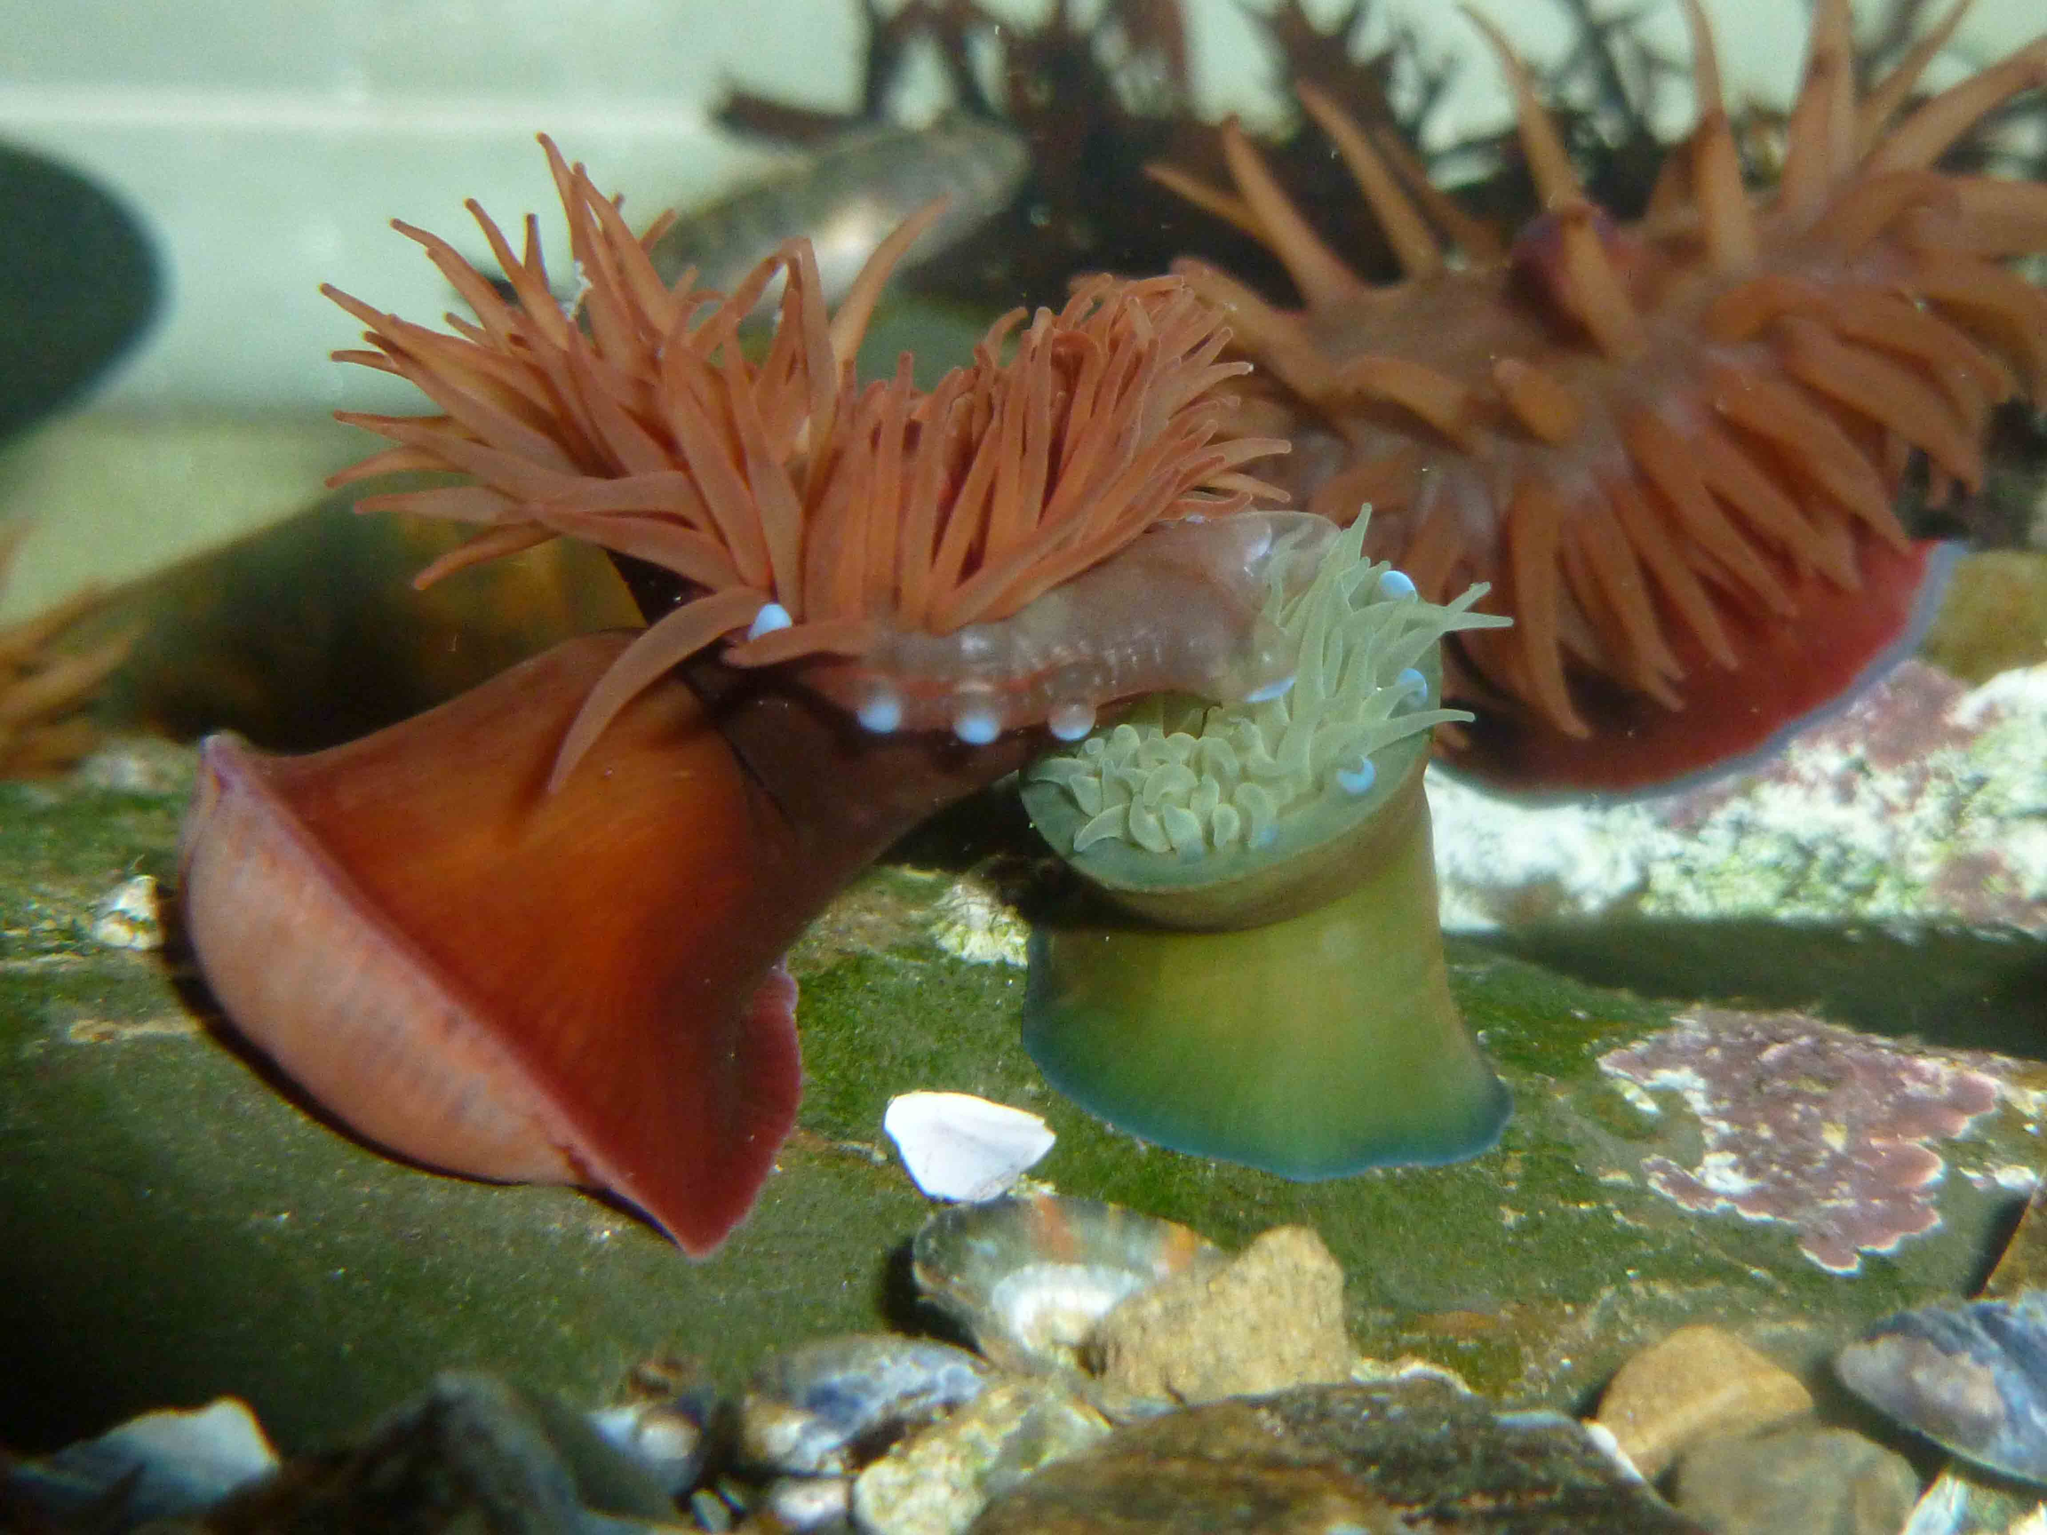
Red on green Beadlet anemone aggression caught on camera by Rob Durrant in the aquarium he has created at home.

TWENTY THIRTEEN BIOBLITZ
Plans for a public bioblitz at Woolacombe on 7th September 2013 are underway with Coastwise taking the lead. The aim is to make this a major event as part of the UNESCO Biosphere’s 10th Anniversary celebrations by engaging the community in a wildlife census. They will be guided by experts drawn from a variety of local and county-wide organisations. Something to which everyone can contribute.
Woolacombe is a wonderful location, with important coastal and marine habitats, and Woolacombe Green will be an ideal base for activities. The Biosphere Foundation’s new trailer & Dome, equipped with microscopes and other field studies equipment, will provide an excellent hub for a cluster of offerings from supporting organisations. Our thanks are due to Parkin Estates, the Parish Council, and the National Trust for their support, and to the numerous naturalists and organisations that have already expressed interest in taking part.
A full programme of public events such nature walks and rock-pool rambles will run throughout the day, recording, photographing, and identifying plants and animals, all with the help of expert enthusiasts. The resulting records will be submitted to national databases and provide the foundation for further local studies.
Anyone interested in getting involved should contact Coastwise Secretary Marjorie Heath. Developments will be reported on the website – see overleaf.

TALES FROM WALES - HOURS ON THE GOWER
May Bank Holiday and 15 members of Coastwise explored the marine life on the other side of the Bristol Channel. In a 3-day event organised by Mavis and Clive Symons the group went on two shore safaris on the Gower Peninsular, guided by marine biologist Judith Oakley (author of the book “Seashore Safaris”).
Eight members preceded this with cruise from Mumbles to Worms Head, visiting nesting sea-bird colonies and catching glimpses of porpoise where feeding gannets were seen. Next day Judith led the Safari onto the rock platform of Worms Head Causeway.
Jim Monroe reports “Judith whet our appetites with suggestions of what we might find under the boulders and overhangs. We were not disappointed. Pencil and golf-ball sponges, huge dead man’s fingers and my own favourites, the elegant anemones were all there to see.” Judith went on to point out rosy featherstars, sea cucumbers, Risso’s crab and sea lemons with spawn.
Monday’s visit to Oxwich Bay held more surprises. Among the gullies and overhangs the finds included male tompot blennies guarding their eggs (Judith’s favourite find of the day), many examples of star ascidians and various species of sea squirts and sponges.”

MICROSCOPY BIG BOOST
Barnstaple Rotary Clubs have generously donated £500, through the good offices of Chris Mandry, for a digital microscope to deliver images to computer screen and via a projector.
Microscope enthusiast Paula Ferris says “With this wonderful and flexible piece of kit viewers can share the thrills of discovery, and capture them for future study, a great aid to identification. Learning to use it to best advantage and to master editing video will be a winter challenge, the results for all to see at the 2013 Bioblitz.”
For the techies: the scope is a Brunel trinocular zoom scope, x10 – x40, with a 3MP USB camera.

A microscope workshop was held in May to trial low mag scopes for viewing the plants and the animals inhabiting the weedy turf. Forty took part in Mortehoe Village Hall, and with a wide array of scopes to choose from had ample opportunity for individual and collaborative study. Their enthusiasm was fired.
Phycologist Sarah Hotchkiss introduced groups to the intricacies of seaweed collection and identification, often necessitating a microscope, and demonstrated how to compile a personal herbarium. Several members later bought scopes, and former member Gerry Bonnici donated a learner’s digital scope for members to borrow.

SUMMER ON THE SHORE
Ten rock-pool rambles were scheduled for the summer and only two had to be cancelled despite one of the wettest summers on record. Although sometimes attendances were lower than in previous years, two at Croyde (2) and one at Barricane each attracted over 50 people.
Close views of plenty of fish, crabs, and snails in basecamp’s new tank compensated for a relatively poor showing of the more exciting marine animals. On one particularly good visit to Barricane snorkelers Jim and Clive found several Janolus cristatus sea slugs and Rob Durrant added several more to his 2012 tally of unusual but tiny slugs.
Happily Combe Martin Museum & the National Trust now also run rock-pooling programmes and a touch of glamour attended our joint safari with the Museum. A BBC Countryfile magazine reporter and cameraman covered it for the July issue.

Several members took part in the MBA’s bioblitz at Cawsand in July which despite difficult weather clocked up a surprising number of species. Thanking MBA organiser Jack Sewell Eric Pufahl noted that “We all learnt a great deal that should help us prepare for our BioBlitz next year at Woolacombe.”
Chris Mandry raised £50 for Coastwise with his ID quiz of undersea wildlife and the winner, Paula Ferris, looks forward to a Lundy trip on the calmer waters of 2013.

Shore Thing visits to Lee and Abbotsham attracted welcome visitors. Nigel Phillips representing Somerset Wildlife Trust joined us at Lee and generously donated a copy of his book The Somerset Coast – a living landscape. At Abbotsham we were joined by college student Christina Hunt whose enthusiasm has led her to volunteer with the National Trust’s beach ranger team this summer. We hope she will join us again.

With great sadness we record the death on 16th August of Doreen Finch, a founder member and staunch friend of Coastwise.
Our sympathies are extended to her family, together with thanks for the warmth and generosity they have shown to Coastwise on Doreen’s behalf.
Further information from mheath2025@aol.com
www.coastwisenorthdevon.org.uk
Edited by Paula Ferris. September 2012

