

August 2013
BioBlitz Programme
10.00 Sea Mammal Watch Morte Point
10.30 Seine Netting from the beach
10.30 Birds and their Habitats
11.00 Strandline Hunt
11.30 Seeking Butterflies in the dunes
12.00 Seashore Safari at Woolacombe
12.30 Seashore Safari at Barricane
12.30 Dune Plants, Lichens and Fungi
13.00 Seaweed Search
13.00 Seal Survey from Morte Point
13.30 Seine Netting from the beach
13.30 Insect Hunt
14.30 Coombesgate’s Rocks &Lichens
15.00 Sea Mammal Watch Morte Point
15.00 Stream Life
16.30 Sand Dunes for beginners

Special Attractions Planned
Species detection – scientists at work
Moth & mammal trapping revelations
Photos from the deep - Ilfracombe Dive Club
Shell sifting - British Conchology
Society
Secret lives – Micro world & Web cam screenings
Salt-water Aquarium
Family Activities Tent

SHORE THING
Coastwise’s good record of monitoring was recently commended by MBA project co-ordinator Fiona Crouch. She & two colleagues joined over a dozen of us under the guidance of Pip Jollands at Lee Bay in July, quadrats to the ready. Earlier half a dozen had turned out for the more arduous terrain of Abbotsham, enough to cover the ground thanks to careful planning by our marine advisor, Pip.
Two visits are made to each location every year, the second to Abbotsham in the autumn term by students at Great Torrington School, and to Lee Bay by Coastwise members at 10.30 am on 19th September, when newcomers are welcome to join us.

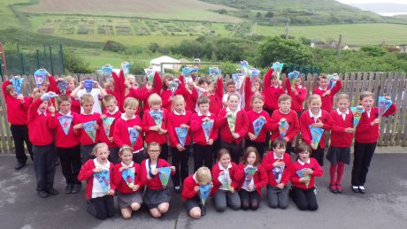

Putting out the flags for BioBlitz, children from Georgeham & Woolacombe Primary Schools do BioBlitz proud. Below – Coastwise Safari on Barricane Beach

7th SEPTEMBER 10.00 am - 6 pm
NORTH DEVON BIOBLITZ
It's hard to believe that almost a year has passed since we started planning the BioBlitz and it is proving to be an amazing collaboration
between naturalists, local groups and individuals, with the National Trust providing special support. Sue Austin reports “It's been a real challenge at times but we are nearly there and eager for the event to take off”. Some could hardly wait. Georgeham and Woolacombe Primary schools have already been getting involved with help from NT’s Joshua Day, and have some stunning artwork to show for it. Joshua reports in the National Trust blog “ From an inspirational art day in Woolacombe Warren, watching badgers, foxes and deer on our new trail cam and seeing some mini beasts in a new light with our microscope camera. The children have designed and created fantastically bright and colourful bunting featuring fauna and flora from the local area. The bunting will be used to decorate the BioBlitz.”
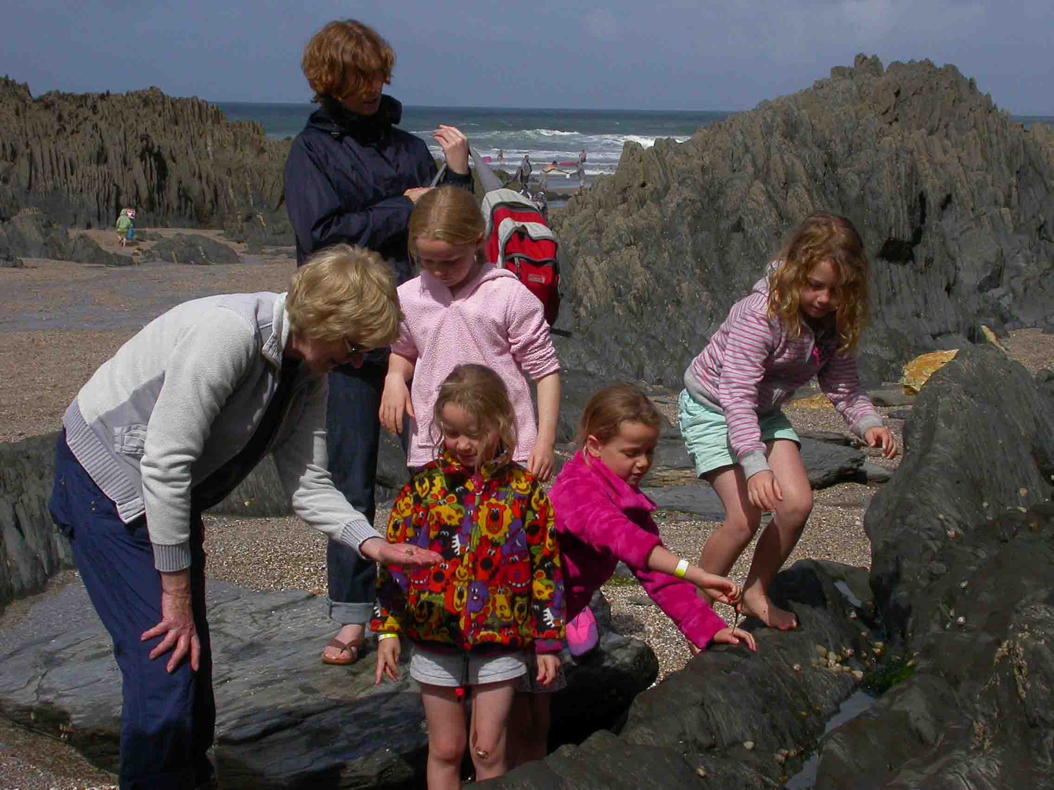
On the day there will be opportunities for everyone to join a survey expedition, a guided walk, get feet wet on a rockpool ramble, peer down a microscope, look at the creatures we find, get arty and crafty in the activity tent or ask an expert who will be on hand to answer wildlife questions. Children’s activities will include a Family Tent with a very special “rock-pool” designed by Joshua.
We want to provide a fun day out for the public and get scientific data for future use. This will be North Devon's first BioBlitz and we hope it will engage and inspire. Want to help? Contact info@coastwisenorthdevon.org.uk or phone Coastwise Secretary on 01271 831190. Best of all – come along on the day.

AUTUMN TALKS PROGRAMME

Programme organisers John Broomhead, Malcolm Roberts & Paula Ferris are proud of the programme on offer this autumn, Coastwise’s 15th talks series. It offers something for everyone – from seals & starfish, by way of canoeing & conservation, to icebergs & ice-cream. Who could ask for more? But will be more including a birding trip bonus.

10th October Members, The Coastwise Programme - BioBlitz & beyond
17th Rob McIntyre, The North Devon coast from a kayak.
24th Sarah Clark, Inshore Fisheries & Conservation
31st Ron Cleevely, George Montagu – the forgotten naturalist?
7th November Andy Torbet, BBC’s Project Iceberg
14th Sue Sayer, Seals
21st John Walters, Secret Life of the Undergrowth
28th Geoff Hocking, Hockings Ice cream
5th December AGM. Chris Mandry & Paula Ferris Hidden worlds
12th Holly Morgenwroth, Echinoderms: stars of shore & museum

MISCELLANY
Time off in Looe Jim Monroe reports: the beaches of the Looe Voluntary Marine Conservation Area were the destination for 22 Coastwise members when they set out for a weekend on the coast of S.E. Cornwall in April. Heather Buttivant, the chair of Looe Marine Conservation Group was host and guide for two shore surveys as part of a weekend activity organised by Mavis and Clive Symons.
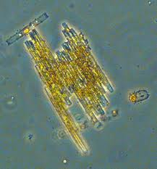
First we joined Heather in mud sieving and rockpooling at Millendreath beach. Heather had suggested that Stalked Jellyfish might be found and we were rewarded when Jay and Di Nicholson found a fine example.
Sunday’s event was a visit to the rocky shores of Hannafore where several interesting finds were made. Five species of sea slug included Limacia clavigera, (Heather’s favourite) and Onchidoris depressa (a first for Heather), while a Sea Hare measuring 17.5 cms. was found by Janice Whittington. Rob Durrant’s mystery find was later identified by Matt Slater of CWT and confirmed by Bernard Picton, as the colonial hydroid Candelabrum cocksii. With a trip to Looe Island for good measure, a great time was had by all.
A few weeks later a dozen or so members took part in the Looe MCG bioblitz, to renew acquaintances and pick up some tips for the North Devon BioBlitz in September.
MBA’s Educators’ Training Janice Whittington and Sandy Johnson relished the opportunity of a weekend training session offered by the MBA in Plymouth. Janice reports “Both of us had a really good time. We learnt a lot and met some lovely people”. The programme included an introductory memory name game, shore activities including, a Shore Thing timed search, a good session on windfarms and Janice’s favourite, a plankton workshop. On the shore Janice noted lots of Wakame and sugar kelp. Good for lasagne apparently. Talking of which – the food was excellent. Many thanks to the MBA for giving Coastwise members this opportunity.
Marine Conservation Areas were on the agenda at Park School. Robert Down was interviewed by students for their project to provide a Coastwise perspective.
Members are increasingly interested in sharing their experiences and photos of marine life, so Janice Whittington has agreed to set up a Facebook Group. It is open to members and potential members who belong to Facebook. A dozen or so have already joined and are finding it useful for the exchange of information and photographs of recent sightings.
Included amongst them are plenty of Robert Durrant’s photographs, some of which have been selected to illustrate the National Biodiversity Network’s Annual Report, a fitting tribute to his skills and enthusiasm.

Seaside Science In May Sarah Hotchkiss & Janice Whittington took a group of Bath Spa literature students to a Gosse haunt, Hele Beach, as part of a project to study writing the environment. With Sarah’s encouragement Coastwise has lent support for an application to FLAG for funding to develop the project.

Coastwise member Brenda Aydon got a glimpse behind the scenes at Ilfracombe Aquarium when she volunteered to contribute to the ethical review element of their zoological license application . She tells us it was really interesting, and heartening, to see how much they knew and cared about the animals.

Atlantic Array application Between August and 16 September those who want to play a part in the planning process must register their interest with The Planning Inspectorate. Coastwise is reviewing the Environmental Statement with particular regard to the impact on marine vertebrates, and cultural impact on the seascape with a view to registering concerns and asking for mitigation.
Fullabrook grant Coastwise has won small grant from the Fullabrook Community Fund for the purchase of a powerful Windows 8 laptop computer for presentations and digital microscopy.

Coastwise members held their first Microscope Session of the year courtesy of Ilfracombe Sub Aqua Club in March with a presentation on the laptop featuring video clips of tiny crabs and other crustaceans, tube worms, sea spiders and sea snails. These filmed via the trinocular zoom microscope & digital camera grant funded by Barnstaple Rotary clubs. Many members had not used microscopes before, so teaching material was prepared to help their first steps.

Samples included plankton trawled from Ilfracombe Harbour by Robert Down who says those new to plankton were fascinated by the variety, and the favourite was the mesmerising Bacillaria paradoxa, or "carpenter's rule".

Seaweed expert Sarah Hodgkiss demonstrated how much can be revealed, even at low magnification, and new microscope users were surprised at the structure that is visible, and the animal life that inhabits some quite unpromising-looking weed.

Edited by Paula Ferris, August 2013
www.coastwisenorthdevon.org.uk

