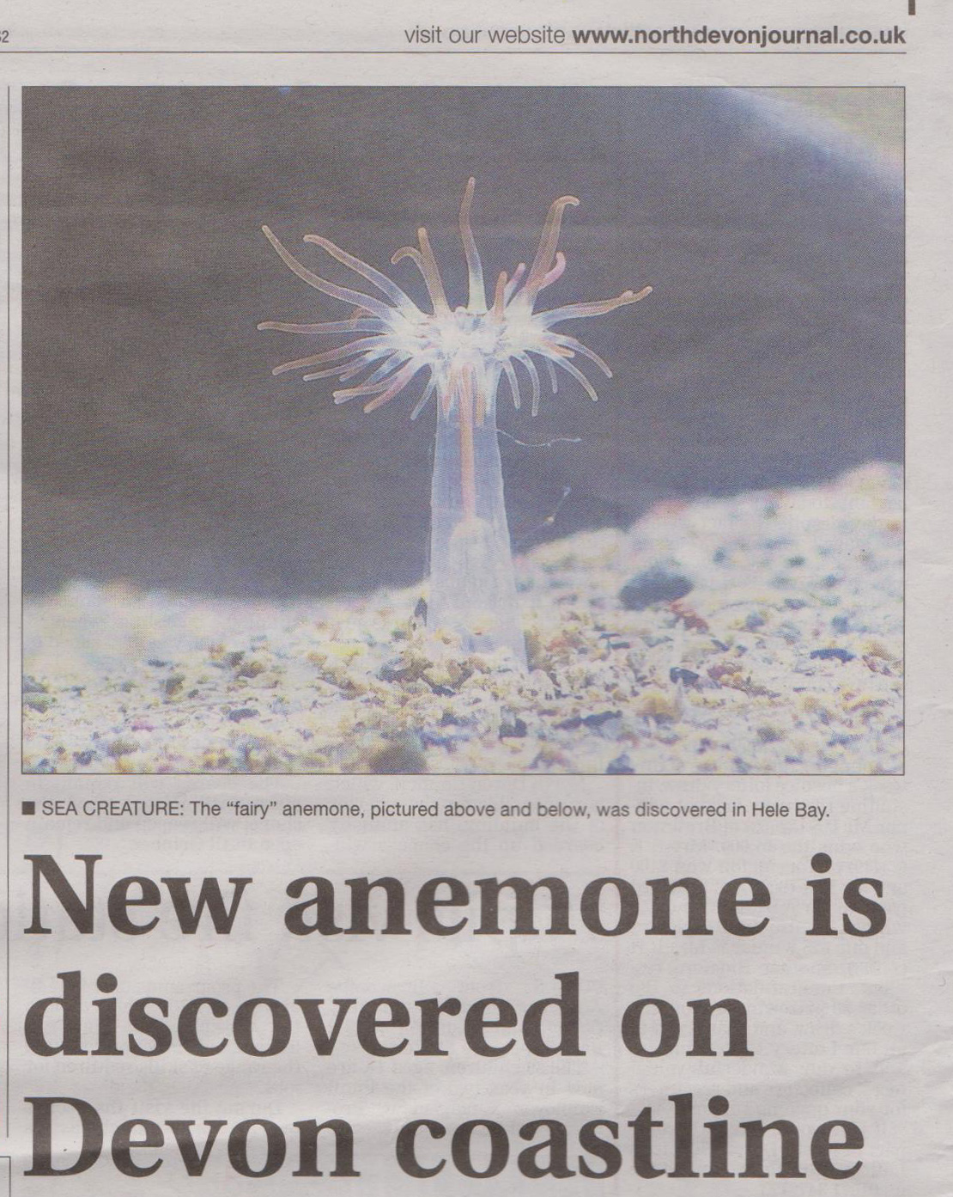

January 2015


AUTUMN PROGRAMME
Marine litter, sand & the coastline emerged as themes for the session. BBC campervan cook Martin Dorey’s early talk fired us up with his 2 minute beach clean challenge. Later AONB’s Clean Marine Officer Natalie Gibb gave us the context with a thorough overview of the topic. She got some of us beach cleaning with encouragement from the Biosphere’s Kate Weld, and Rose Roberts, Beach Ranger at Ruda, Croyde. Their presence at meetings has been very welcome & indicative of support from the local concerns they represent.

Margaret Sutcliffe’s introduction to the geology of our coast set the scene, encompassing massive change over millions of years. Fellow geologist Paul Madgett had a narrower focus on the product of the rocks - sand, sadly with a growing litter quotient.

Sand and sediment movement was also a major feature of the storms of 2014, Marine biologist Keith Hiscock’s topic. His evidence showed, perhaps surprisingly, that marine life appeared to have undergone little lasting damage. Storms may be part of the natural order & survivable. Marine litter is not and remains a serious challenge to our coast, as perhaps climate change – a topic for the current programme.

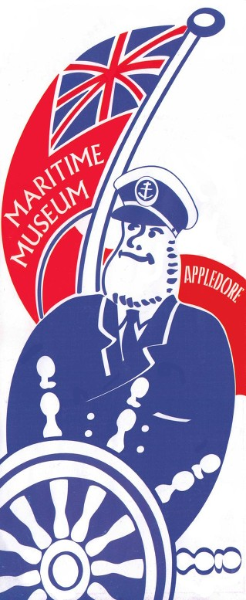
We also heard from members Jim Monroe & Paula Ferris enthusing about plankton and seasonal shore life. Chris Mandry rescued a mix-up of dates with a presentation on shipwrecks he happened to have to hand, jolly good it was too. Something completely different came from Jenny Carey-Wood & Chrissie Hines from North Devon+ who reported on the Fisheries Local Action Group projects which have released so much creative energy locally - sustainable development embracing the arts, crafts, & science as well as fisheries & food.

A highlight of the term was a very successful visit to Appledore Maritime Museum. We enjoyed a warm welcome & a perfect mix of guided talks from helpful expert volunteers and plenty of free time in a museum that impresses well beyond its size.

This beautiful tiny anemone was discovered by member Robert Durrant at Hele Bay in September. Unable to identify it, he consulted experts but was only able to convince them of its significance after taking the excellent back-lit photograph. He established from this that it was a form of Aiptasiogeton pellucidus. He then succeeded in getting this particular form added as an ‘accepted variety’ var comatus to WoRMS (World Register of Marine Species), and so was able to submit on iRecord the first official UK record." Congratulations to Robert for his discovery and diligence.

Robert’s record of finds over the last few years has been impressive. Almost single-handed, he has done much to populate the marine map of Bideford Bay and bring it to the attention of decision makers. He has forged links with the Conchology Society & the MBA, as well as individual experts such as Bernard Picton, David Fenwick & Doug Herdson. Through them & their involvement as validators for irecord he is striving to make sure that local records reach the National Biodiversity Network so they can contribute to MCZ decisions.
MBA Bioblitz – Jay Nicholson and Jim Monroe represented Coastwise at the MBA’s bioblitz at Mount Batten which by all accounts was a great success with 1027 species recorded. Coastwise friend David Fenwick says he had 9 new marine species to report to Aphotomarine.

Lichens on the shore have been largely overlooked by Coastwise to date but no longer. Maxine Putman & Tony Holwill led a lichen walk at Putsborough in October organised by Janice Whittington. Their expertise and enthusiasm made converts of us and we are now keen to learn more about the lichens that inhabit lower reaches of the shore.

The VMCA conference organised by Cornwall Wildlife Trust took place at the Eden Project in November this year. Janice Whittington led Coastwise representation and spoke about our microscope workshops, a North Devon speciality.

The Shore Thing Newsletter Pip Jollands, our expert mentor, reported our Harpoon Weed (Asparagopsis armata) find at Abbotsham, a first there for the invasive species. She added that whilst we have not noticed any particular changes in species over the years, our species identification has got stronger. Indeed.

The Devon Maritime Forum meeting held in Exeter in November was attended by Robert Down and Paula Ferris. North Devon got plenty of coverage, a welcome sign of the rising interest in our coast, including: VALMER North Devon case study update, the winter storms report, & Braunton floods review, with a showing of North Devon Boat stories.

Even more marine in North Devon – Starting now North Devon AONB’s Year of marine and coastal initiative 2015-16 with a focus on:

The Clean Marine project, Seascape, Skates and Rays and the North Devon Aquaculture Centre investigation, for which a Feasibility Study workshop was held on 29th January attended by Coastwise representatives. Watch this space.

Estuary Birds - 5 members of Coastwise became counters for the monthly Wetland Bird Survey after Tim Jones’ talk on the subject a year ago, and are now experienced active contributors. Keep up the good work: John Broomhead, Mark Haworth-Booth, Dave Jenkins, Keith Prescott, Eric Pufahl, and Janice Whittington who join long-standing counter Rob Jutsum. Related issues are being raised with the Estuary Forum to secure a better future for estuary birds facing disturbance from many quarters.

Last term’s bird trip to Isley took place on 28 November, one of the few dates when time and tides were propitious. The weather held out for the reserve itself, where several spoonbills were seen together with plenty of waders and ducks. Rain brought the remainder of the visit to a premature end but not before some got rather wet.

Membership has never been stronger, with 14 new members joining for the autumn term and another 4 this session. Most meetings are full, there is an exciting buzz about them, most gratifying to the speakers and organisers. The Library’s Williamson Room is an ideal venue we hope to keep though alternatives are being explored should library developments mean we have to vacate.

Committee members were re-elected at the December AGM with Dave Jenkins, Liz Weston and Chris Mandry agreeing to attend as observers. Christmas lunch, which followed, at the Imperial Hotel was so well received that organiser John Broomhead has already booked our place for next year.

Website & photographs – Congratulations to the new members making use of the Gallery to share their photographs, something that thanks to Robert Down is now quite straightforward. Entrants to the

Photo Competition on 19th February are encouraged to post their entries afterwards.
Forthcoming Events
Coastwise Thursday morning meetings , 9.45, Barnstaple Library
February
5 Water management & North Devon - Brett Grosvenor, Environment Agency
11 Topsham Bird Trip
12 Sailing for an Eco Lifestyle - Mukti Mitchell, writer & eco advocate
13 DWT meeting, Rob Durrant Seashore Explorations, 7.30 Castle Centre
19 Members’ Session & Photo Competition
26 More tales from the shore, the intriguing lives of our marine animals - Paul Naylor, marine biologist

March
5 Latest climate change projections – a Devon perspective – Doug Eltham, Devon County Council
12 Strolling the shore, from top to bottom – Shore Safari Team
13 South-West Marine Ecosystems conference details on application
19 Members’ Beach Visit to Hele & Microscope Workshop at Ilfracombe Dive Club.

Edited by Paula Ferris, January 2015
www.coastwisenorthdevon.org.uk

